BOOKSTORE SALES ANALYSIS
SQL Data Analyst ProjectName: Pavitra KM
Background: M.Sc. Statistics
Institute: Besant Technologies, Bangalore
Project Domain: SQL

1. PROJECT OVERVIEW
This project is a part of my Data Analytics training at Besant Technologies. The objective is to design a relational database for a Bookstore and perform Sales Analysis using SQL.As an M.Sc. Statistics graduate, I applied my statistical and database knowledge to solve a real-world business problem for a Bookstore owner.

- BUSINESS PROBLEM
A Bookstore owner needs answers for:
- Which books are generating more revenue?
- What is the total quantity sold per book?
- How to efficiently manage Books, Authors and Customers data?

- TOOLS & SKILLS USED
SQL:Oracle / SQL Developer
Concepts: ER Design, Primary Key / Foreign Key, Joins, GROUP BY, Aggregate Functions (SUM), Indexing
Data Quality: Handled Referential Integrity Errors (ORA-02291)

4.DATABASE DESIGN

Tables Designed: AUTHORS, BOOKS, CUSTOMERS, ORDERS, ORDER_DETAILS, INVENTORY.

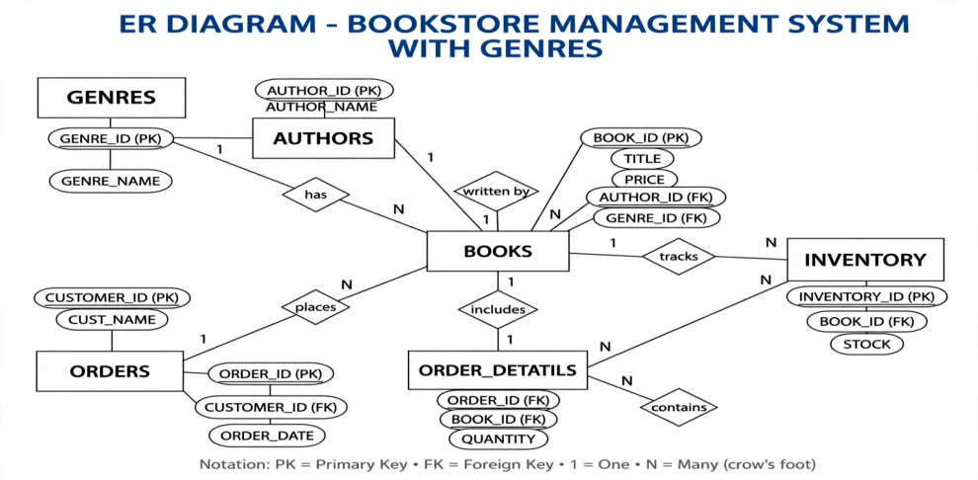
Fig4.1:ER diagram for bookstore management systems

5.TABLE CREATION

-- 01_CREATE_TABLES.SQL
CREATE TABLE GENRES (GENRE_ID NUMBER PRIMARY KEY, GENRE_NAME VARCHAR2(50));
CREATE TABLE AUTHORS (AUTHOR_ID NUMBER PRIMARY KEY, AUTHOR_NAME VARCHAR2(100));
CREATE TABLE BOOKS (BOOK_ID NUMBER PRIMARY KEY, TITLE VARCHAR2(100), AUTHOR_ID NUMBER REFERENCES AUTHORS(AUTHOR_ID), PRICE NUMBER);
CREATE TABLE CUSTOMERS (CUSTOMER_ID NUMBER PRIMARY KEY, CUST_NAME VARCHAR2(100));
CREATE TABLE ORDERS (ORDER_ID NUMBER PRIMARY KEY, CUSTOMER_ID NUMBER REFERENCES CUSTOMERS(CUSTOMER_ID), ORDER_DATE DATE);
CREATE TABLE ORDER_DETAILS (ORDER_ID NUMBER REFERENCES ORDERS(ORDER_ID), BOOK_ID NUMBER REFERENCES BOOKS(BOOK_ID), QUANTITY NUMBER);

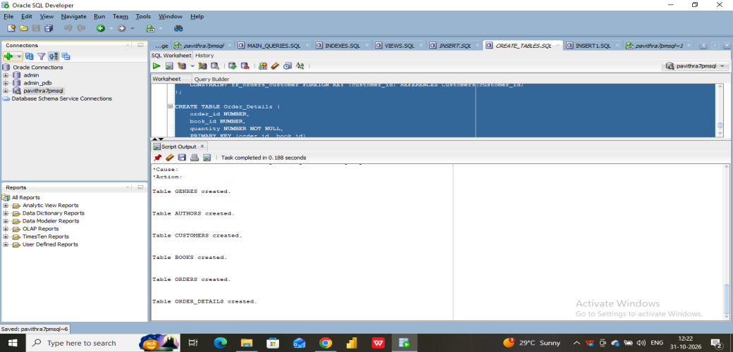
Figure 2: Table Creation Output

6.DATA INSERTION
-- 02_INSERT.SQL
INSERT INTO AUTHORS VALUES (1, 'S.C. Gupta');
INSERT INTO AUTHORS VALUES (2, 'Dr. B. Gupta');
INSERT INTO BOOKS VALUES (1, 'Fundamentals of Statistics', 1, 450);
INSERT INTO BOOKS VALUES (2, '7 Sampling Techniques', 2, 380);
COMMIT;

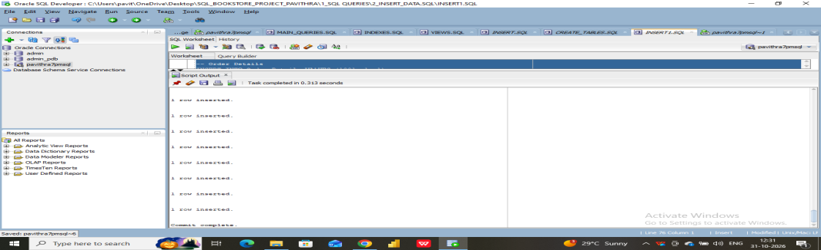
Figure 3: Data Insertion
7.MAIN ANALYSIS QUERY - SALES REPORT
-- Business Question: Show Total Quantity and Total Sales per Book
SELECT b.BOOK_ID, b.TITLE, a.AUTHOR_NAME, b.PRICE, SUM(od.QUANTITY) AS TOTAL_QTY, SUM(od.QUANTITY * b.PRICE) AS TOTAL_SALES
FROM BOOKS b
JOIN AUTHORS a ON b.AUTHOR_ID = a.AUTHOR_ID
JOIN ORDER_DETAILS od ON b.BOOK_ID = od.BOOK_ID
GROUP BY b.BOOK_ID, b.TITLE, a.AUTHOR_NAME, b.PRICE
ORDER BY TOTAL_SALES DESC;

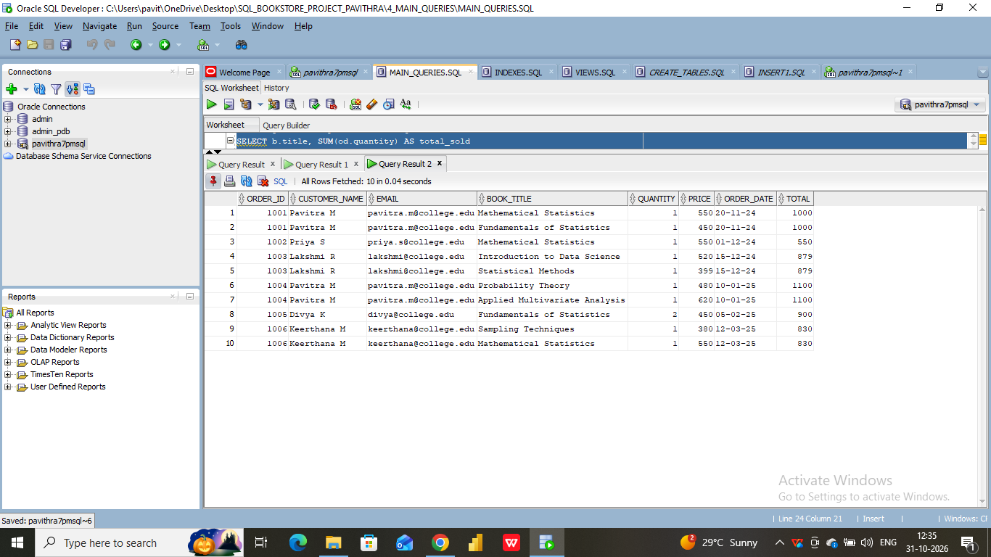
Figure 4: Query to Find Bestsellers

Insights:
Fundamentals of Statistics (Rs. 450) - Quantity Sold Analyzed7 Sampling Techniques (Rs. 380) - Quantity Sold Analyzed Query provides total revenue per book for inventory decisions.

- OPTIMIZATION
CREATE INDEX idx_book_title ON BOOKS(TITLE);
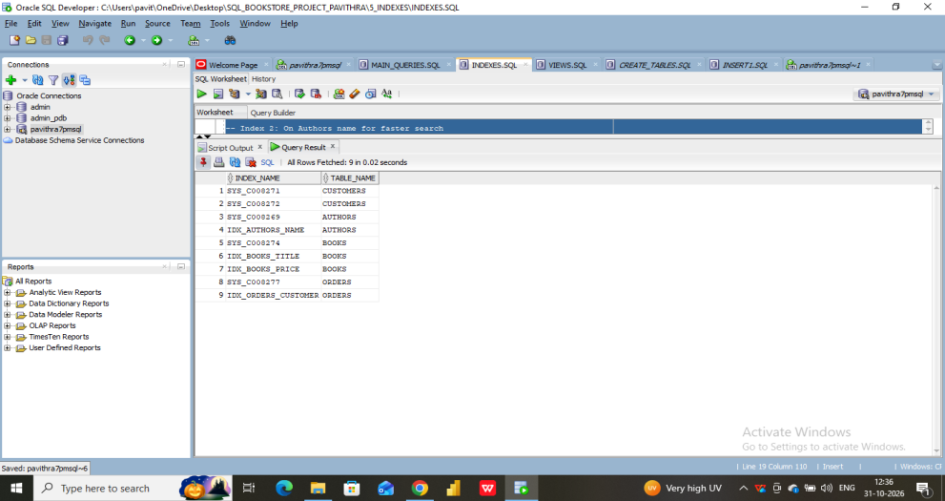
Figure 5: Optimized Query Result

9. CONCLUSION
Successfully designed database and generated sales report using advanced SQL. This project demonstrates my SQL and analytical skills as part of Data Analytics training at Besant Technologies

